—------------------------------------------------------------------------------------------------------------------------------------------

ggplot(unique_trips, aes(x = trip_length)) +

geom_histogram(binwidth = 60, fill = "blue", alpha = 0.7) +

labs(title = "Distribution of Trip Lengths", x = "Trip Length (seconds)", y = "Frequency") +

theme_minimal()

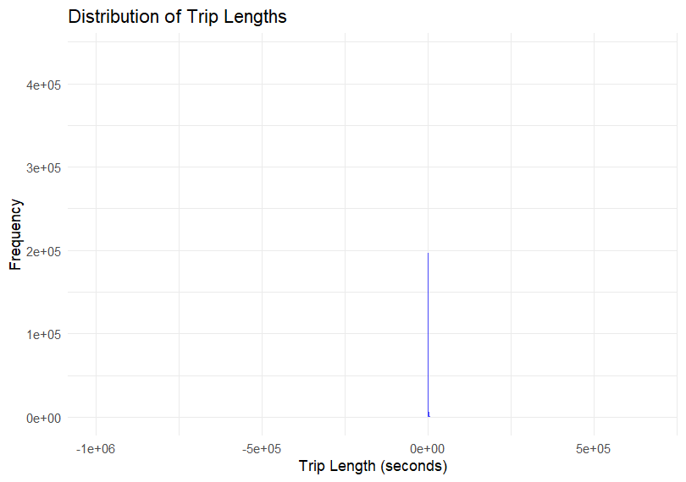

ggplot(filtered_trips_2, aes(x = trip_length)) +

geom_histogram(binwidth = 60, fill = "blue", alpha = 0.7) +

labs(title = "Distribution of Trip Lengths", x = "Trip Length (seconds)", y = "Frequency") +

theme_minimal()

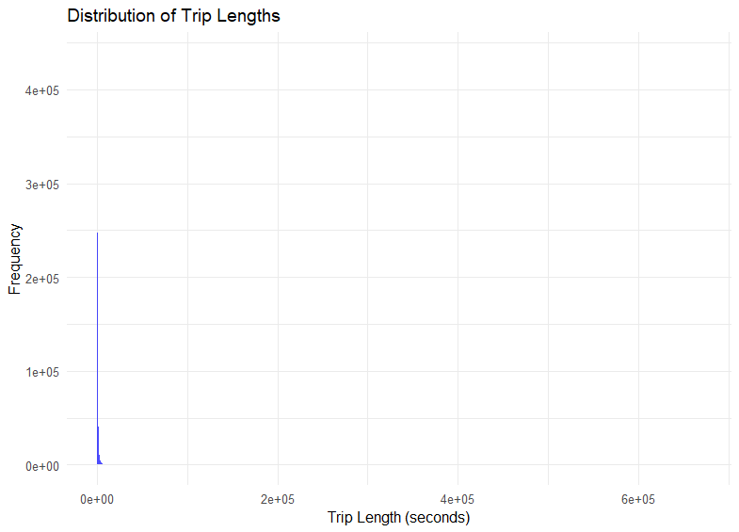

# Histogram of trip lengths in minutes

ggplot(filtered_trips_2, aes(x = trip_length/60)) +

geom_histogram(binwidth = 60, fill = "blue", alpha = 0.7) +

labs(title = "Distribution of Trip Lengths", x = "Trip Length (mins)", y = "Frequency") +

theme_minimal()

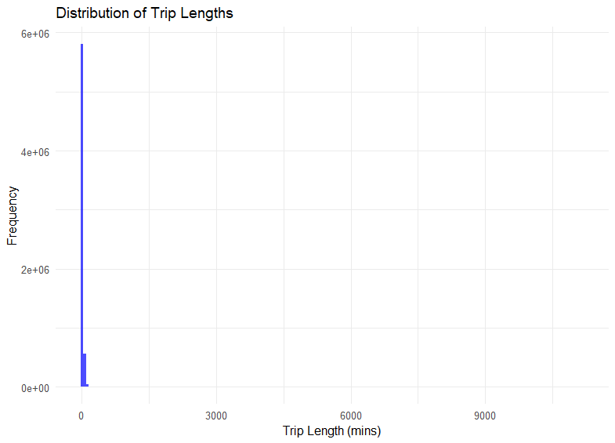

# Histogram of trip lengths less than 24 hours

ggplot(filtered_trips_2 %>% filter(trip_length < 86400), aes(x = trip_length/60)) +

geom_histogram(binwidth = 60, fill = "blue", alpha = 0.7) +

labs(title = "Distribution of Trip Lengths", x = "Trip Length (mins)", y = "Frequency") +

theme_minimal()

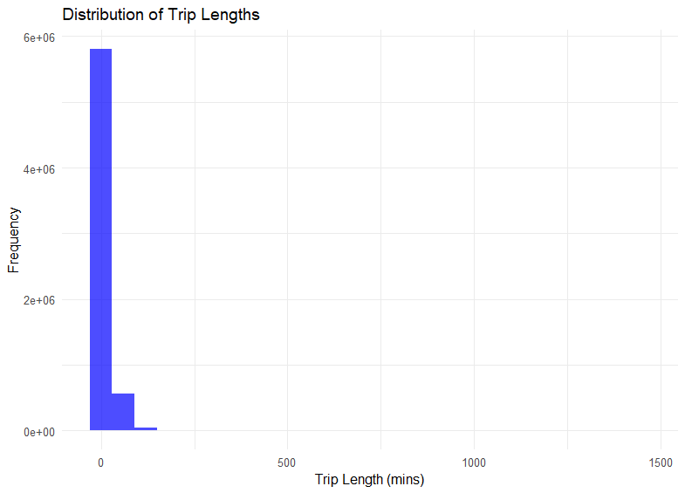

# Histogram of trip lengths less than 1 hour in seconds

ggplot(filtered_trips_2 %>% filter(trip_length < 3600), aes(x = trip_length)) +

geom_histogram(binwidth = 60, fill = "blue", alpha = 0.7) +

labs(title = "Distribution of Trip Lengths", x = "Trip Length (seconds)", y = "Frequency") +

theme_minimal()

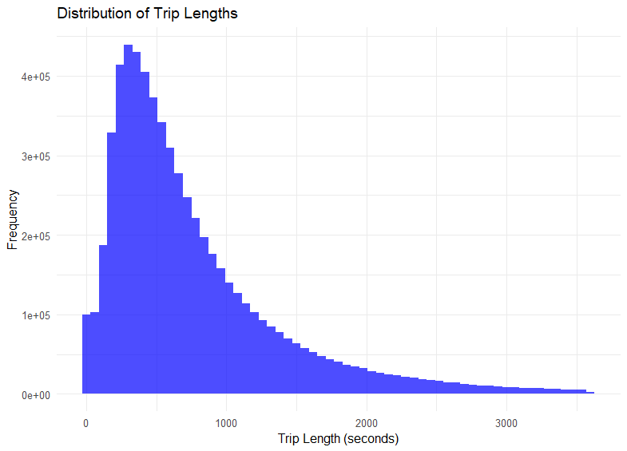

—------------------------------------------------------------------------------------------------------------------------------------------

ggplot(all_trips) +

geom_density(aes(x = hour(started_at), fill = "Start Time"), alpha = 0.5) +

geom_density(aes(x = hour(ended_at), fill = "End Time"), alpha = 0.5) +

labs(title = "Density of Trip Start and End Times",

x = "Hour of the Day",

y = "Density",

fill = "Legend") +

scale_x_continuous(breaks = 0:23) +

scale_fill_manual(values = c("Start Time" = "blue", "End Time" = "red")) +

theme_minimal()

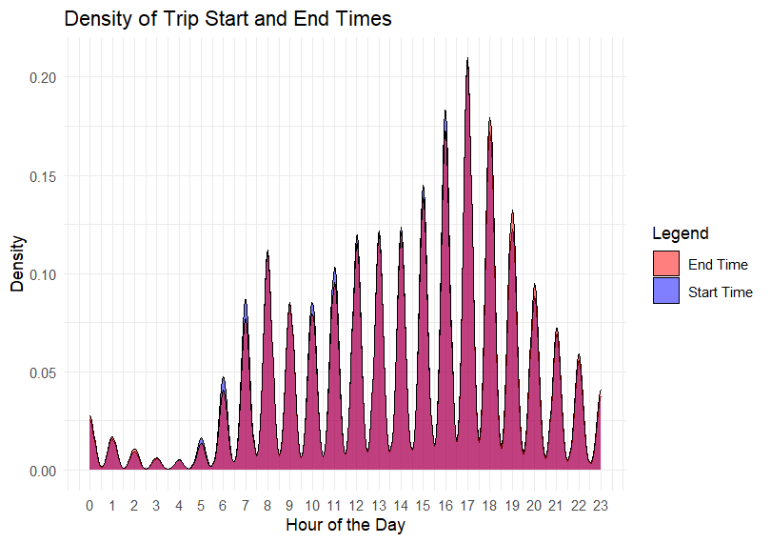

# Extract hour and minute of the day from started_at and ended_at

filtered_trips_2 <- filtered_trips_2 %>%

mutate(

start_time_minute = hour(started_at) * 60 + minute(started_at) + second(started_at) / 60,

end_time_minute = hour(ended_at) * 60 + minute(ended_at) + second(ended_at) / 60

)

# Plotting density plots

ggplot(filtered_trips_2) +

geom_density(aes(x = start_time_minute, color = "Start Time"), fill = "blue", alpha = 0.3) +

geom_density(aes(x = end_time_minute, color = "End Time"), fill = "red", alpha = 0.3) +

scale_x_continuous(name = "Time of Day (Minutes)", breaks = seq(0, 1440, by = 60), labels = function(x) format(as.POSIXct(x * 60, origin = "1970-01-01", tz = "UTC"), "%H:%M")) +

labs(title = "Density of Trip Start and End Times", color = "Event") +

theme_minimal()

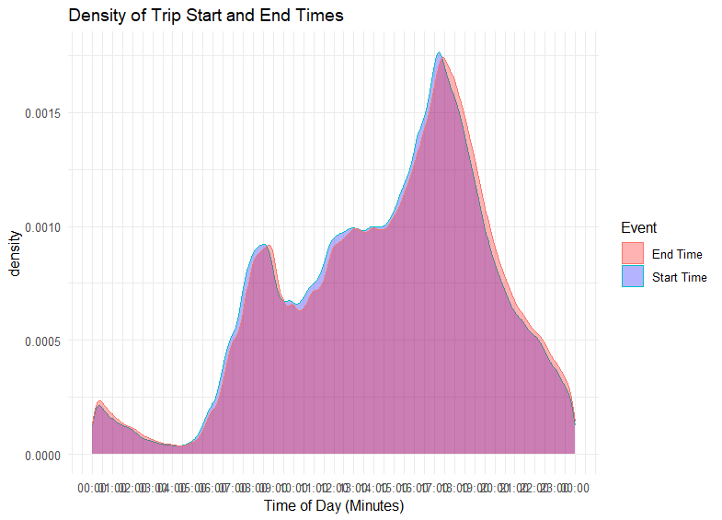

—------------------------------------------------------------------------------------------------------------------------------------------

# Create pie charts for each rideable type

ggplot(membership_by_bike_type, aes(x = "", y = percentage, fill = member_casual)) +

geom_bar(stat = "identity", width = 1) +

coord_polar("y", start = 0) +

facet_wrap(~ rideable_type) +

labs(title = "Membership Distribution by Rideable Type",

fill = "User Type",

y = "Percentage") +

theme_void() +

theme(legend.position = "right") +

geom_text(aes(label = paste0(round(percentage, 1), "%")),

position = position_stack(vjust = 0.5))

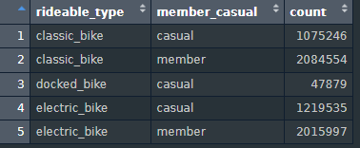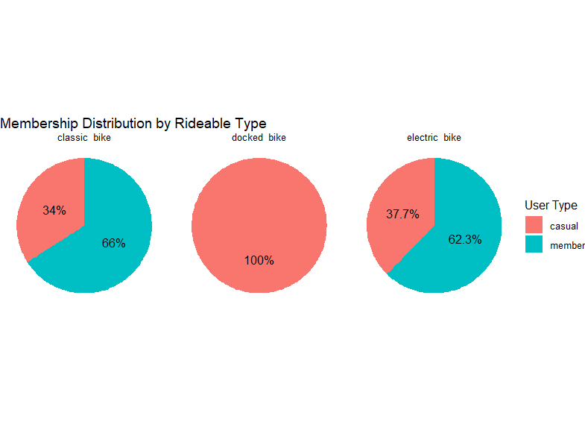

—-----------------------------------------------------------------------------------------------------------------------------------------------------------------------------------

# histogram of days of week

ggplot(frequency_day_of_week_started, aes(x = day_of_week_started, y = n)) +

geom_bar(stat = "identity", fill = "blue", alpha = 0.7) +

labs(title = "Frequency of Days of the Week", x = "Day of the Week", y = "Frequency") +

theme_minimal()

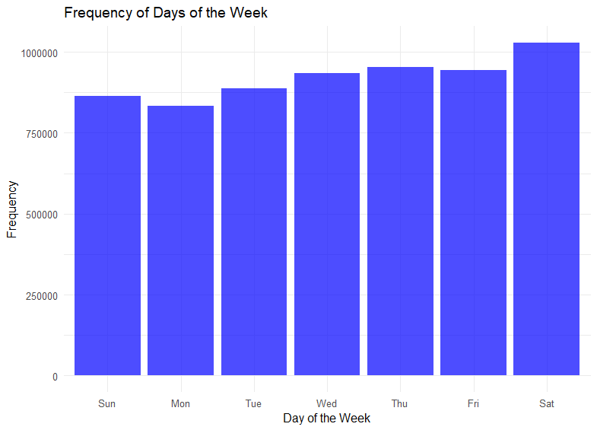

—-----------------------------------------------------------------------------------------------------------------------------------------------------------------------------------

# map start_lat and start_lng to see if they cluster around specific points to indicate stations

ggplot(head(filtered_trips_2, 100), aes(x = start_lat, y = start_lng)) +

geom_point() +

labs(title = "Scatter Plot of lat vs. long",

x = "start_lat",

y = "start_lng") +

theme_minimal()

100 =

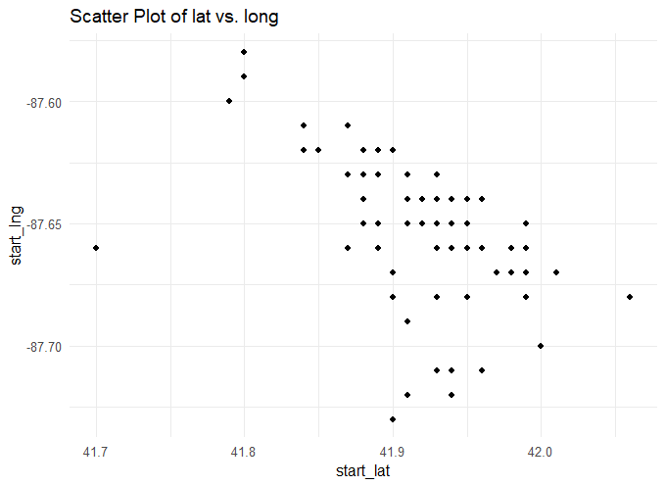

1000 =

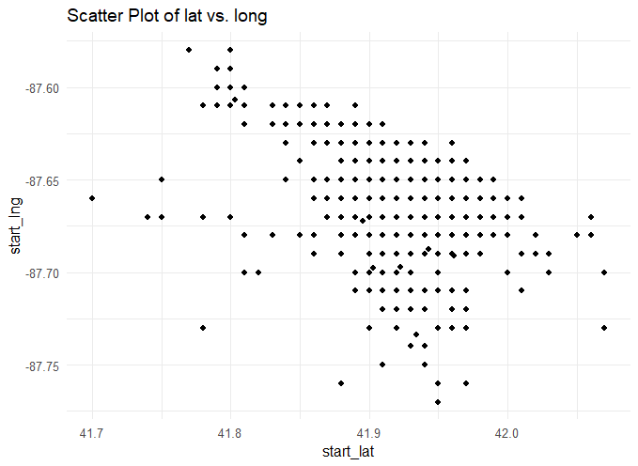

10000 =

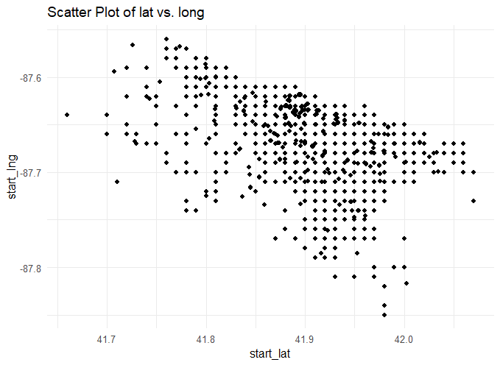

—-----------------------------------------------------------------------------------------------------------------------------------------------------------------------------------

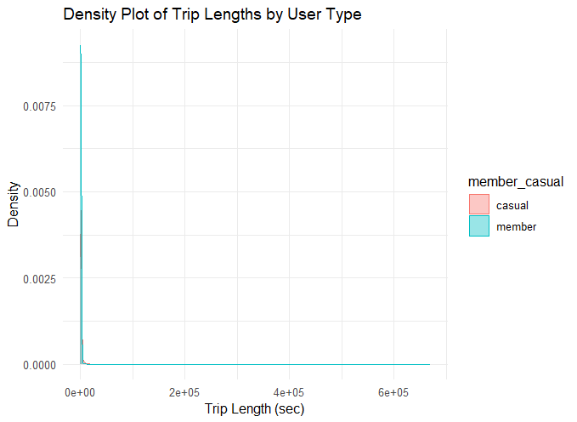

# group by user type density plot

ggplot(filtered_trips_4 %>% filter(trip_length < 3600), aes(x = trip_length, color = member_casual, fill = member_casual)) +

geom_density(alpha = 0.4) +

labs(title = "Density Plot of Trip Lengths by User Type",

x = "Trip Length (sec)",

y = "Density") +

theme_minimal()

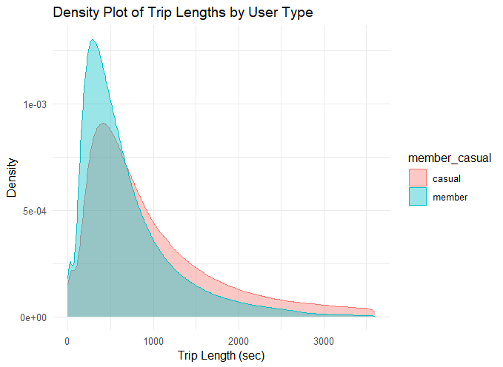

—-----------------------------------------------------------------------------------------------------------------------------------------------------------------------------------

# viz for the number of rides by rider type

filtered_trips %>%

mutate(weekday = wday(started_at, label = TRUE)) %>%

group_by(member_casual, weekday) %>%

summarise(number_of_rides = n(), average_duration = mean(trip_length)) %>%

arrange(member_casual, weekday) %>%

ggplot(aes(x = weekday, y = number_of_rides, fill = member_casual)) + geom_col(position = "dodge")

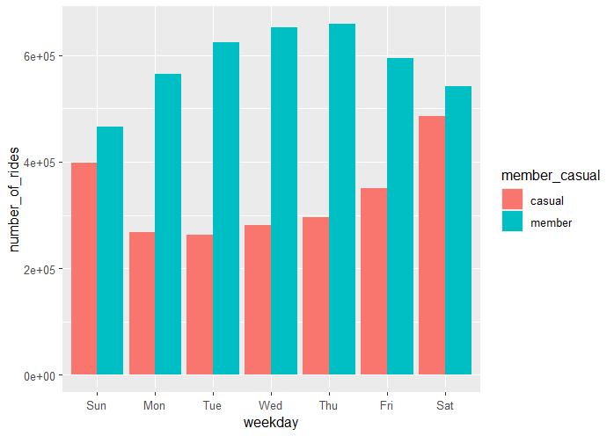

# viz for average duration

filtered_trips %>%

mutate(weekday = wday(started_at, label = TRUE)) %>%

group_by(member_casual, weekday) %>%

summarise(number_of_rides = n(), average_duration = mean(trip_length)) %>%

arrange(member_casual, weekday) %>%

ggplot(aes(x = weekday, y = average_duration, fill = member_casual)) + geom_col(position = "dodge")

